Link to register for Parkrun: register | parkrun UK
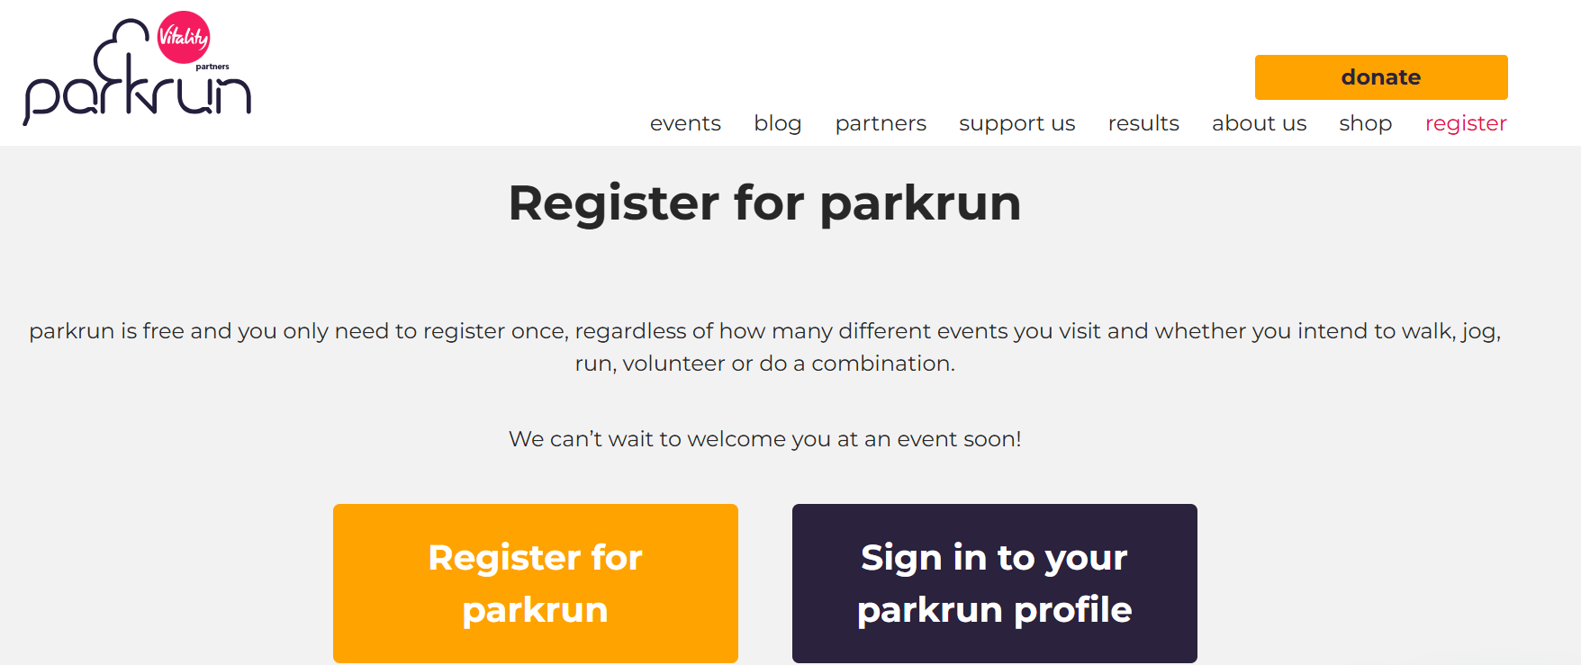

Register online – it’s quick & easy!
Go to the parkrun registration page and select Register for parkrun.
- Choose your country (i.e. UK if you’re in Glasgow)
- Complete the registration form with the following details:
  - First name (the name you are most known by)
  - Surname (this will appear in CAPITAL LETTERS)
  - Nearest parkrun / Home parkrun
    - Select your nearest event or preferred location
    - The information button will take you to the parkrun map, where you can search by your area or postcode
  - Gender
  - Date of birth – Format (DD/Month/Year)
  - Email address
  - Postcode
  - Email subscription preferences – Yes or No
  - General exercise question
  - Ethnic group
  - Health question
  - How you heard about parkrun
  - Emergency contact name and telephone number
  - Tick agreement to the terms and conditions
Once completed, click CHECK FORM
💡 Helpful tip: Next to each question, there is an information icon that provides additional guidance if you need help completing the registration
CHECK YOUR INFORMATION & REGISTER
You will receive your confirmation email within 10 minutes - parkrun profile
This will include -
Your parkrun ID is: A11111111 - This is the number printed underneath your barcode which you also use to log in to your profile.
The events use barcodes to identify participants.
Click on the link on your email to obtain your Barcode & print it off
You need your barcode to register your runs & results
NOW Click on Unique links for your barcode & MY LINKS
Get your barcode
Update your Password & click on Groups
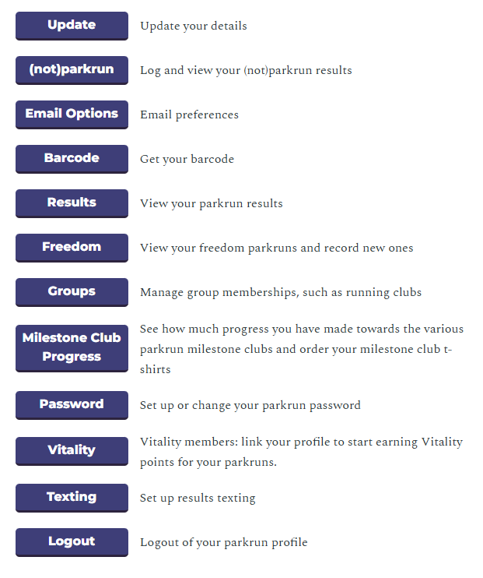
Click on groups & search for Chartered Institute of Building Run Club
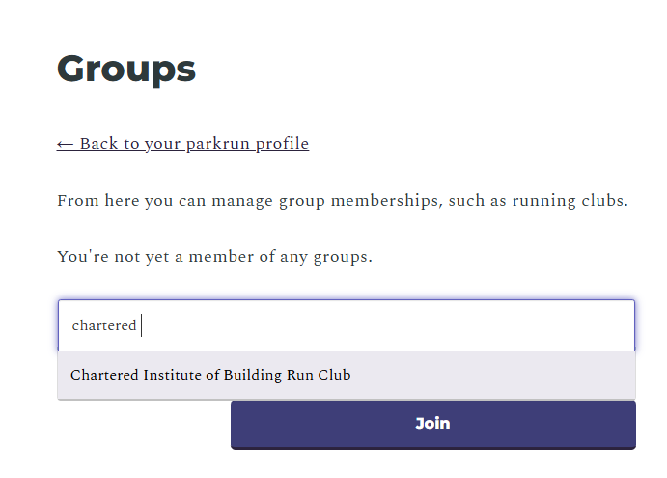
Click Join - You are now a member of the CIOB Run Club… BEST OF LUCK!

